Network Configuration for LTIM Solutions

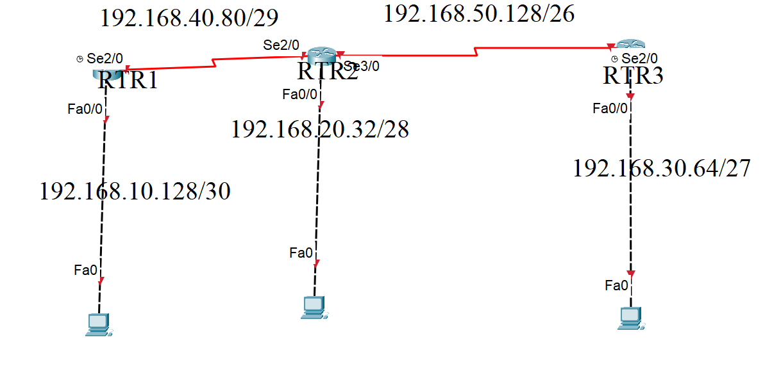
LTIM Solutions is a global IT services company with branches across multiple regions. The organization’s infrastructure consists of routers, switches, and end devices such as PCs and servers. To streamline communication, the management has decided to implement IP addressing across its network infrastructure.
As the Network Administrator, your responsibility is to design and implement the network infrastructure by assigning appropriate IP addresses to all PCs and router interfaces.
Network Setup Details:
- The company uses three core routers, each of which will be connected to end devices.
- You are required to configure IP addresses on all router interfaces and PCs, as discussed during class.
Configuration Requirements:
- Router Naming Convention:
  - (YourName)-Core1
  - (YourName)-Core2
  - (YourName)-Core3
- Security Configuration:
  - Set a login banner:
  - ENTRY RESTRICTED – WITHOUT APPROVAL
  - Configure an enable password secured with MD5 authentication.
- Implementation Instructions:
  - Write all the configuration commands clearly on paper before implementation, also write the sub netting for all networks given above.
  - Submit the written commands to your trainer on 3rd October.
  - Ensure you understand each configuration command before typing it on the router. Commands entered without understanding will not be accepted.
Important Note:
Candidates who fail to demonstrate knowledge of the above lab configuration will not be allowed to participate in class.
COMMANDS
PC connected to RTR1
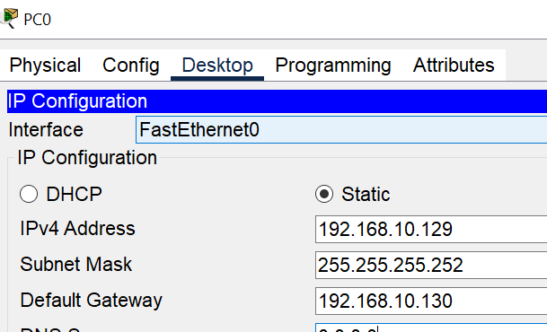
COmamnds in RTR1
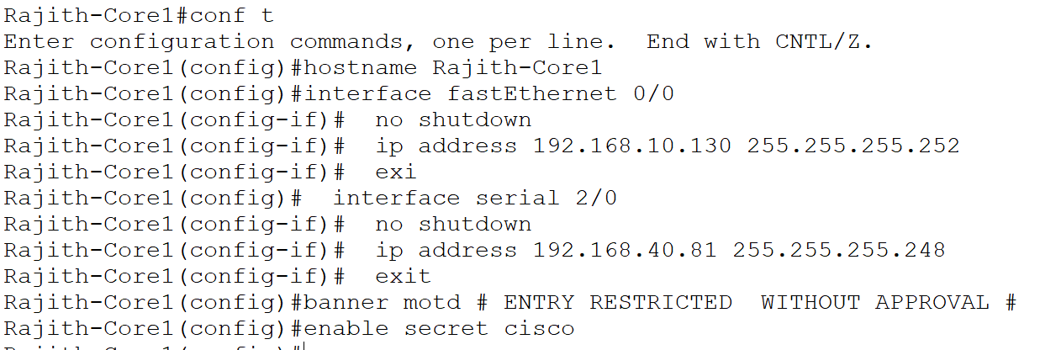
By referring these commands please configure other pcs and routers as well. Take screenshot and save it in a separate word doc.

Any doubts call me – 9008800205 – Rajith Kumar

